**Acknowledgement**

Firstly I would like to thank my lecturer DR. Kalai for teaching us and focusing on Microsoft Azure as in this current time Cloud computing is very important especially in the cooperate environment therefore understanding and being able to apply the knowledge of cloud computing will be very useful and helpful therefore Microsoft is known to be effective and efficient in what they do from a personal and professional view.

Table of Contents

Introduction 3

Background 3

Objectives 3

Scopes 3

Major functions 3

Project Plan 4

WBS 4

Gantt Chart 5

Design: 6

Implementation Architectural Diagram: 6

Design Considerations: 7

Use Case Diagram: 7

Sequence Diagrams: 8

Implementation: 11

Application Development: 11

Azure Publishing: 14

Azure Extra Features: 22

Test Plan & Testing Discussion 23

Unit testing 23

Performance: 25

Conclusion 26

References 27

# Introduction

## Background

Moller-Maersk Group have a division which is Maersk Line which is a global container division and they are the largest container shipping company in the world and it was founded in 1928 therefore their operations are still not cloud based, as they are facing limitations and the solution would be to fully run their services on Microsoft Azure as some of their services are already on Microsoft Azure as the organization approached Microsoft to expand the scope of their relationship as this will help in increasing the organization flexibility and having the organization on a virtualized platform.

## Objectives

* To import, export, and tranship processes.
* To be able to function normally during peak seasons.
* To improve profitability, productivity, and eradicate errors.
* To manage the booking process and confirming the booking.

## Scopes

The scope of the project is to develop a web application that will be able to process the booking of a container as the user will have to be able to manage the whole booking process from schedule search until booking confirmation.

## Major functions

The major functions that the solution will have:

1. Login function that will allow the user to use the services.
2. The sign-up function to allow them to login to the system.
3. Book function to allow the user to book the container according to their needs.
4. View booking to show the user a table of their booked containers.
5. A relation to the database as it will receive and send data to it.
6. Azure deployed and analytics.

# Project Plan

WBS:

|  |  |  |  |  |
| --- | --- | --- | --- | --- |
| WBS | Task Name | Duration | Start | Finish |
| **1** | **Introduction** | **4 days** | **Thu 8/3/18** | **Tue 13/3/18** |
| 1.1 | Background | 1 day | Thu 8/3/18 | Thu 8/3/18 |
| 1.2 | Objectives | 1 day | Fri 9/3/18 | Fri 9/3/18 |
| 1.3 | Scopes | 1 day | Mon 12/3/18 | Mon 12/3/18 |
| 1.4 | Major Functions | 1 day | Tue 13/3/18 | Tue 13/3/18 |
| **2** | **Project Plan** | **2 days** | **Thu 8/3/18** | **Fri 9/3/18** |
| 2.1 | WBS | 1 day | Thu 8/3/18 | Thu 8/3/18 |
| 2.2 | Gantt Chart | 1 day | Fri 9/3/18 | Fri 9/3/18 |
| **3** | **Design** | **4 days** | **Mon 12/3/18** | **Thu 15/3/18** |
| 3.1 | Cloud Design Patterns | 1 day | Mon 12/3/18 | Mon 12/3/18 |
| 3.2 | Implementation Architectural Diagrams | 1 day | Tue 13/3/18 | Tue 13/3/18 |
| 3.3 | Design considerations | 1 day | Wed 14/3/18 | Wed 14/3/18 |
| 3.4 | Modelling | 1 day | Thu 15/3/18 | Thu 15/3/18 |
| **4** | **Implementation** | **12 days** | **Thu 8/3/18** | **Tue 10/4/18** |
| 4.1 | Application Development | 4 days | Fri 16/3/18 | Fri 6/4/18 |
| **4.2** | **Azure** | **12 days** | **Thu 8/3/18** | **Tue 10/4/18** |
| 4.2.1 | Azure Deployment | 3 days | Thu 8/3/18 | Mon 12/3/18 |
| 4.2.2 | Azure Upscaling | 1 day | Mon 9/4/18 | Mon 9/4/18 |
| 4.2.3 | Azure Extra Features | 1 day | Tue 10/4/18 | Tue 10/4/18 |
| **5** | **Test Plan & Testing Discussion** | **2 days** | **Wed 11/4/18** | **Thu 12/4/18** |
| 5.1 | Unit Testing | 1 day | Wed 11/4/18 | Wed 11/4/18 |
| 5.2 | Performance Testing | 1 day | Thu 12/4/18 | Thu 12/4/18 |
| 6 | Conclusion | 1 day | Fri 13/4/18 | Fri 13/4/18 |

Gantt Chart:

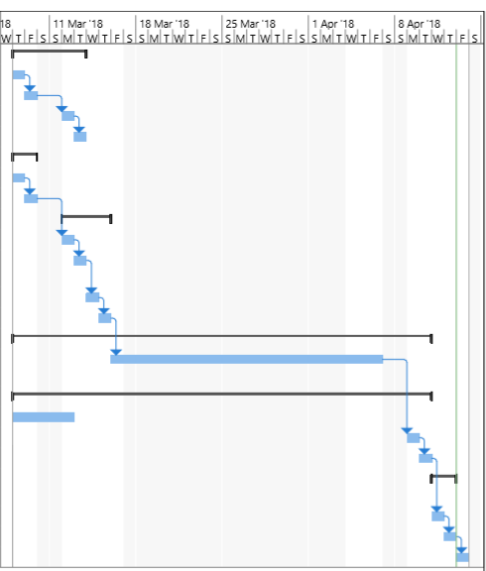

# Design:

## Implementation Architectural Diagram:

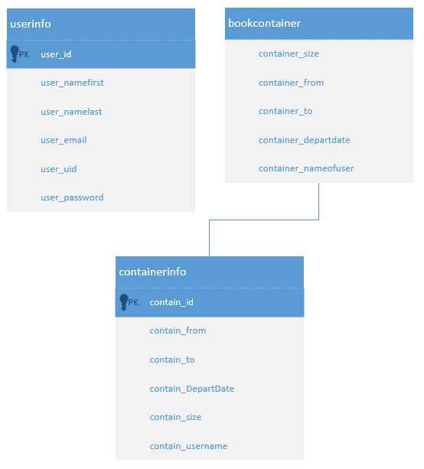

## Design Considerations:

The developer had several design considerations which are upscaling the system to be able to handle the traffic and be able to function smoothly as the developer will be given RM 850 therefore the developer will utilize the creates given to be able to have smooth performance and be able to run the solution.

## Use Case Diagram:

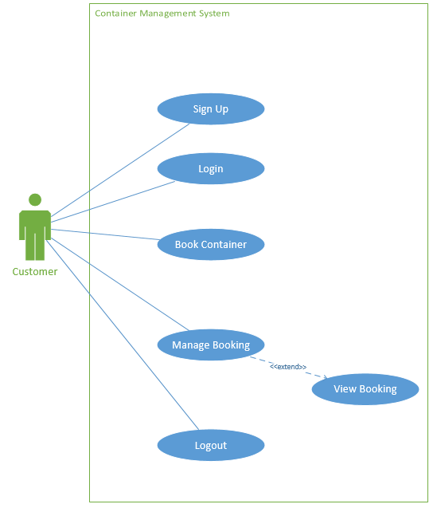

## Sequence Diagrams:

**Login:**



**Sign Up:**



**Book Container:**



**View Booking:**



**Logout:**



# Implementation:

## Application Development:

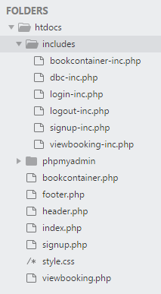

The developer used a local environment by installing and configuring MYSQL, PHPmyadmin, Apache, and created the necessary files and kept them organized as seen in the screen above. The screen above shows the main folder htdocs were the local environment is in the Apache folder therefore being able to run the php files as the developer have two kinds of files which are different depending on the naming which are the normal namings and the files with -inc in them to describe that the folders that have -inc are files responsible for the back end and the normal files are responsible for the view.

**Home screen:**

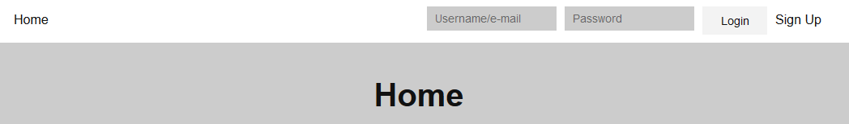

The screen above shows the home screen where the title of the page is displayed in the middle of the page as well have the login function that requires a username or an email with the password, as the developer also kept validation for the login.

**Home after logging in:**

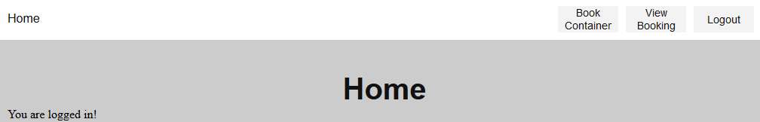

The screen above shows the home page when the user logs in therefore the other functions will show which are the Book Container, View Booking, and the logout.

**Book container:**

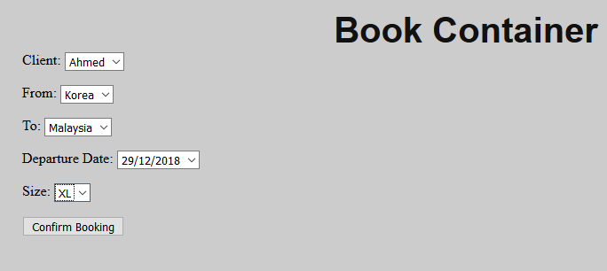

The screen above shows the Book Container page where it allows the user to select the information which are From, To, Departure Date, and the Size. The user will not be able to choose the Client name because it is taken from the Session that was made for the login.

**View Booking:**

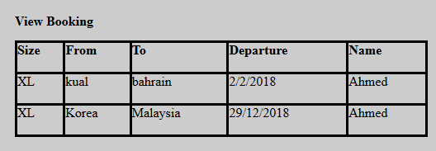

The screen above shows the View Booking page where a table is created depending on the user logged in, as the page will collect the data from the session that was created in the login and compare it with the database and retrieve the other data from the database after verifying.

**Sign Up:**

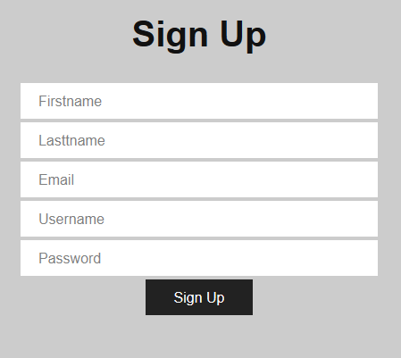

The screen above shows the sign-up page where all the fields are compulsory and validation was made for the sign up as when a field is empty, duplicate username, or/and duplicate email are inputted the page will notify the user.

## Azure Publishing:

**Choosing Web App:**

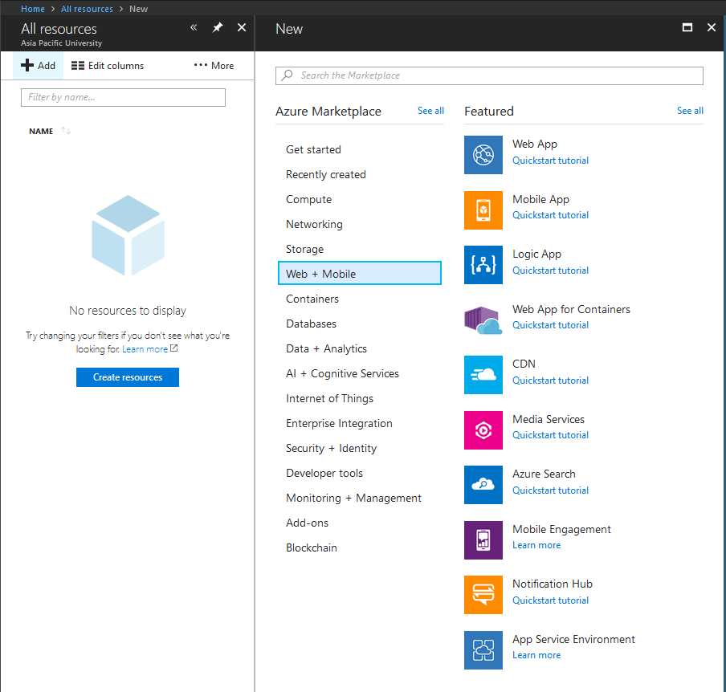

The developer will have to navigate from the Azure portal and choose All resources and click on Web + Mobile and choose Web App.

**Enter information for Web App:**

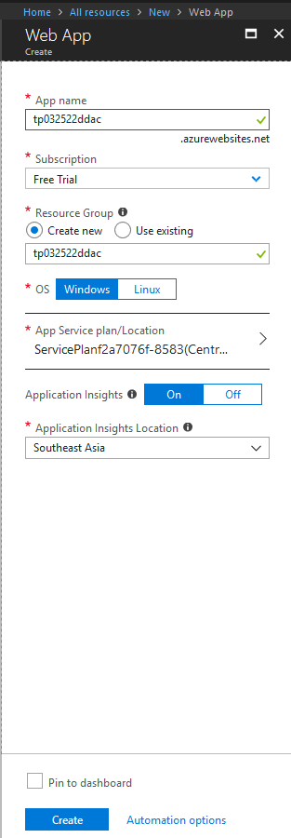

After choosing Web App the developer will have to fill the form to be able to proceed.

**Choosing Source:**

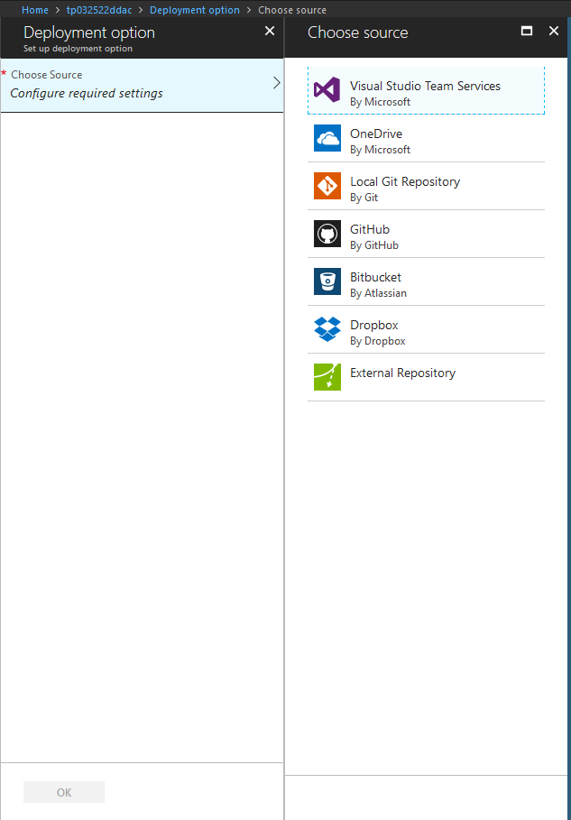

As the requirement for this project the solution is needed to be uploaded to GitHub and then run the Web App from GitHub enabling the user to keep running the Web App even after changing/updating the code in GitHub.

**Choosing Deployment option:**

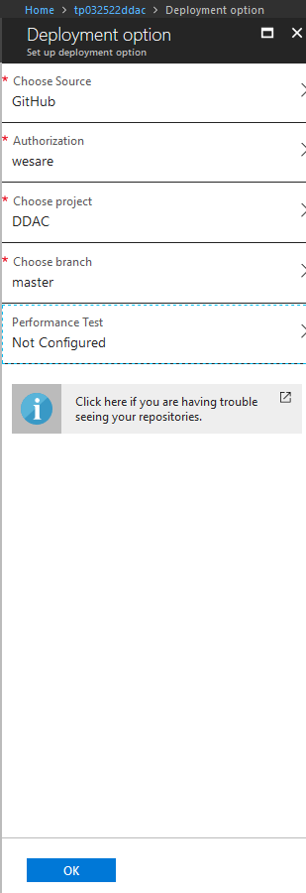

The screen above shows the needed fields to set up GitHub as a source, the developer authorized Azure to use the developer’s GitHub Repository, Project, and the branch.

**Database creation:**

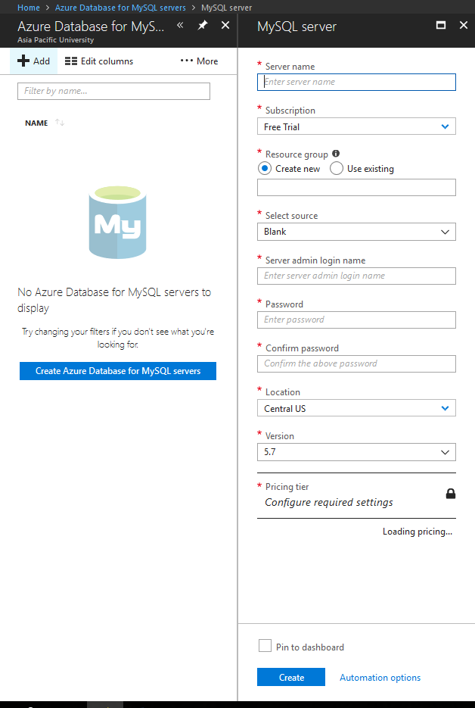

The screen above shows how to set up the MySQL server in Azure, as the developer used MySQL to develop the solution therefore the developer will have to fill the form above by choosing the server name, use existing resource group “tp032522ddac”, give a login name, a password that consist of capital letter, small letter, and number “Ahmed123123”, Location which the developer chose Southeast Asia, and the version unchanged “5.7”.

**Web App Information:**

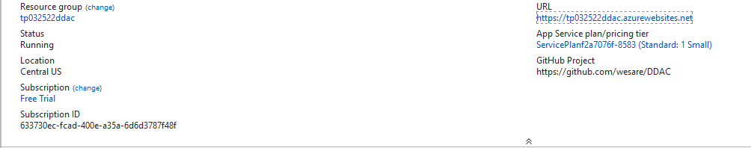

After creating the Web App the information of the Web App is displayed in the screenshot above.

**Database Information:**

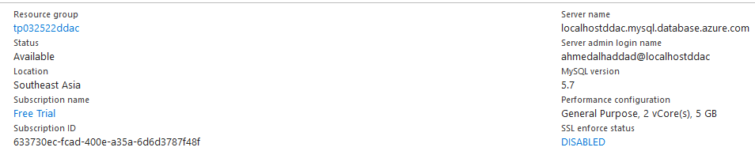

The screen above shows the information of the Azure database as the server name was used to and the performance configuration that was chosen.

**Azure Web App Run:**

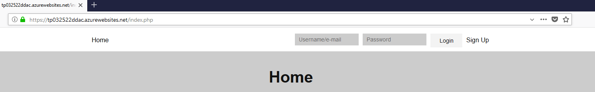

The screenshot above shows the link that the developer used for running the solution as it shows that the Web App is running using Azure.

**Azure Database Monitoring:**

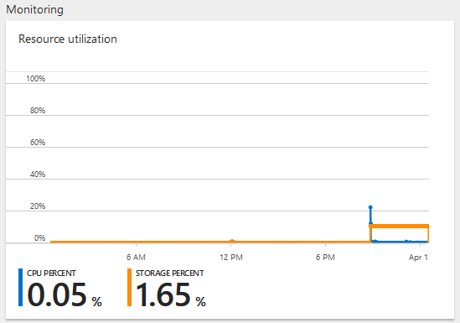

Azure enables the user to monitor the analytics of the database as the screen above shows the usage of the CPU and the how much of the storage is used.

**Azure Upscaling:**

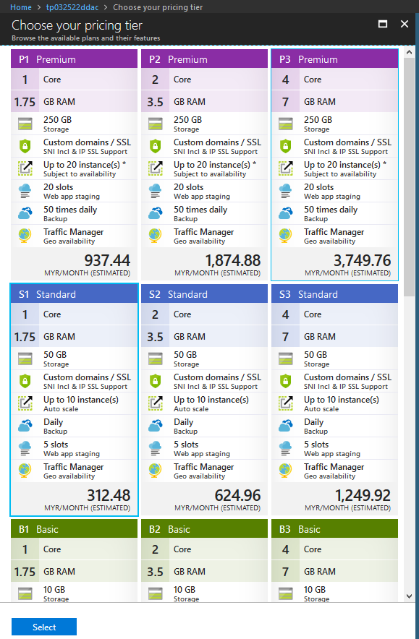

The Web App will always need and have a minimum of Standard S1 Plan as it have the minimum needs of the organization as they will need storage, traffic managing, enough instances, as the backup is daily.

## Azure Extra Features:

**Allow database Usage:**

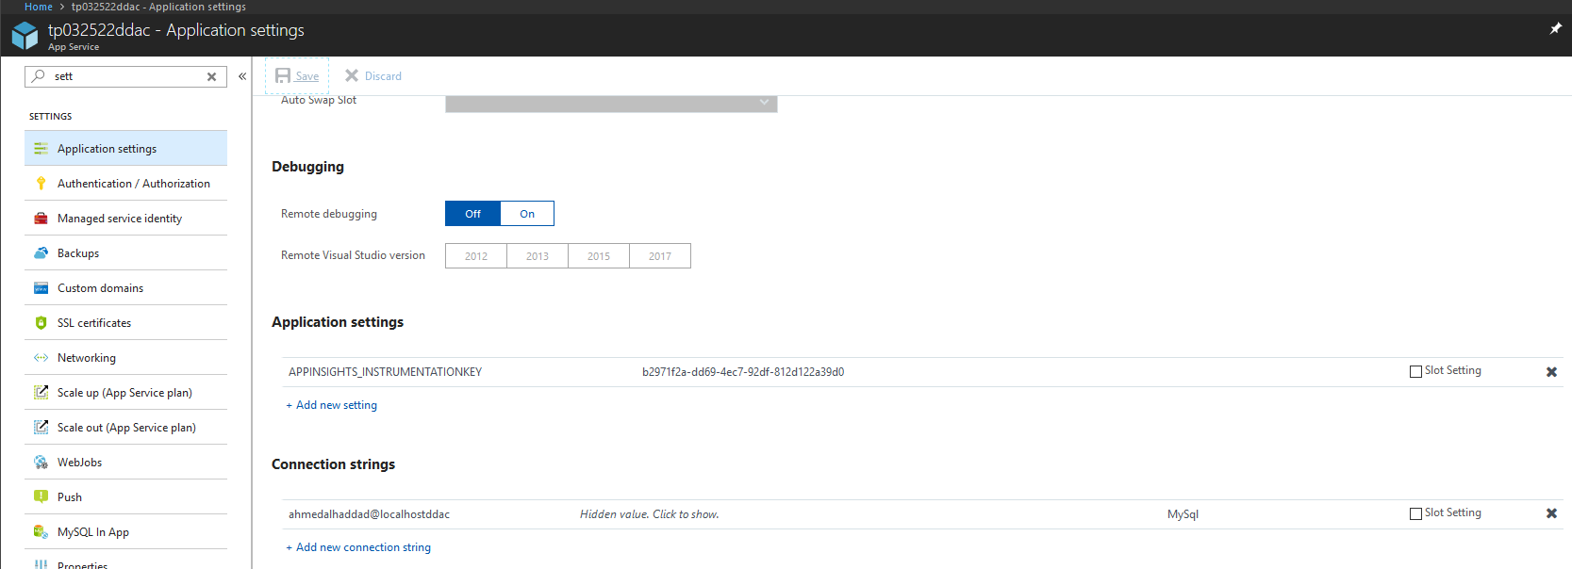

The developer had to do changes to be able to use database therefore the first step was to add the Connection strings therefore matching the database information.

**Editing Database security:**

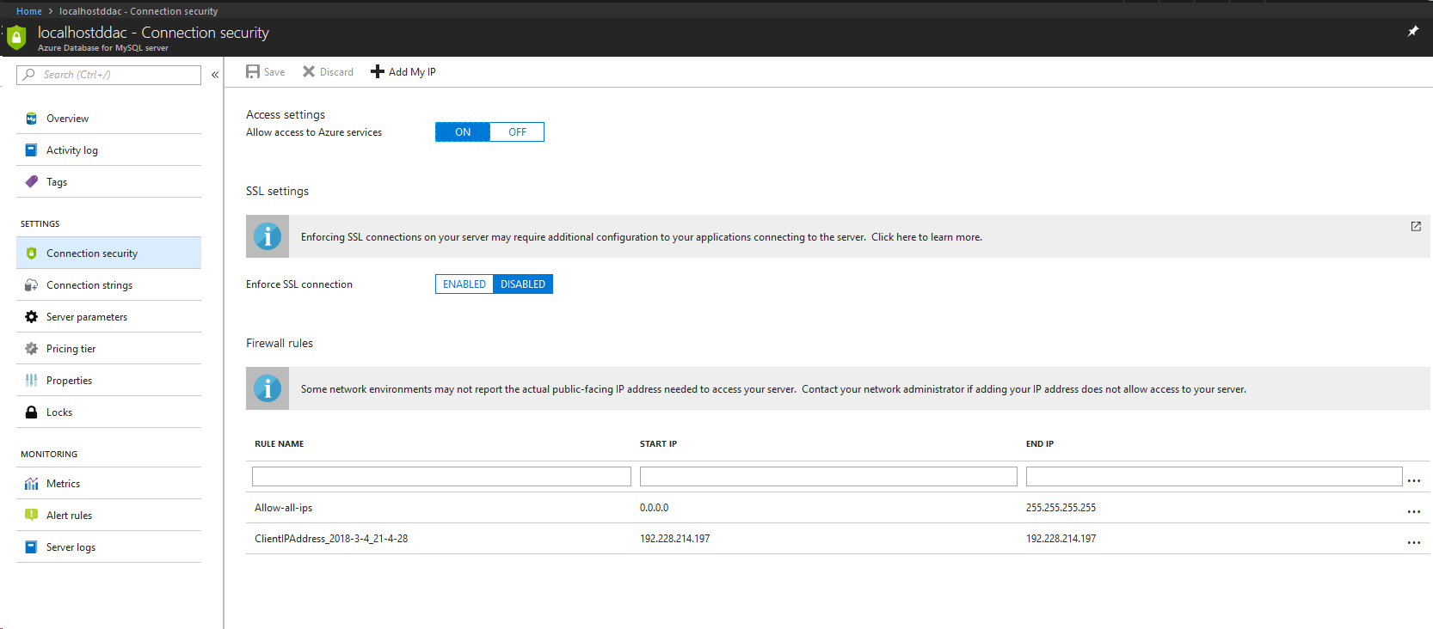

The screenshot above shows the second step that the developer took to be able to use the database which is switching ON Access settings, Disable SLL connection, Add All ips from 0.0.0.0 to 255.255.255.255.

# Test Plan & Testing Discussion

## Unit testing

**Signup:**

|  |  |  |  |  |
| --- | --- | --- | --- | --- |
| Test Case No. | Username/Email | Password | Expected Output | Actual Result |
| 1 | Amdalhad*****@gmail.com | ****** | Sign up success. | Taken Username/Email. |
| 2 | Amdalhad*****@gmail.com | ****** | Sign up success. | Empty Field to fill. |
| 3 | Amdalhad*****@gmail.com | ****** | Sign up success. | No page found. |
| 4 | Amdalhad*****@gmail.com | ****** | Sign up success. | No server response. |
| 5 | Amdalhad*****@gmail.com | ****** | Sign up success. | Successful. |

**Login:**

|  |  |  |  |  |
| --- | --- | --- | --- | --- |
| Test Case No. | Username/Email | Password | Expected Output | Actual Result |
| 1 | Amdalhad*****@gmail.com | ****** | Login to main page. | Wrong Username. |
| 2 | Amdalhad*****@gmail.com | ****** | Login to main page. | Wrong Password. |
| 3 | Amdalhad*****@gmail.com | ****** | Login to main page. | No Connection. |
| 4 | Amdalhad*****@gmail.com | ****** | Login to main page. | No page found. |
| 5 | Amdalhad*****@gmail.com | ****** | Login to main page. | Successful. |

**Book Container:**

|  |  |  |  |
| --- | --- | --- | --- |
| Test Case No. | Name | Expected Output | Actual Result |
| 1 | Ahmed | Booking Successful. | No database connection. |
| 2 | Ahmed | Booking Successful. | No dropbox displays. |
| 3 | Jackson | Booking Successful. | No information displays to choose. |
| 4 | Jackson | Booking Successful. | Server response error. |
| 5 | Jackson | Booking Successful. | Successful. |

**View Booking:**

|  |  |  |  |
| --- | --- | --- | --- |
| Test Case No. | Name | Expected Output | Actual Result |
| 1 | Ahmed | View Booking Table. | No table. |
| 2 | Ahmed | View Booking Table. | All users’ bookings display. |
| 3 | Jackson | View Booking Table. | Missing Column. |
| 4 | Jackson | View Booking Table. | No database connection found. |
| 5 | Jackson | View Booking Table. | View Booking Table. |

**Logout:**

|  |  |  |  |
| --- | --- | --- | --- |
| Test Case No. | Username/Email | Expected Output | Actual Result |
| 1 | Amdalhad*****@gmail.com | Logout Successfully. | No page found. |
| 2 | Amdalhad*****@gmail.com | Logout Successfully. | No server Response. |
| 3 | Amdalhad*****@gmail.com | Logout Successfully. | Logout Successfully. |

## Performance:

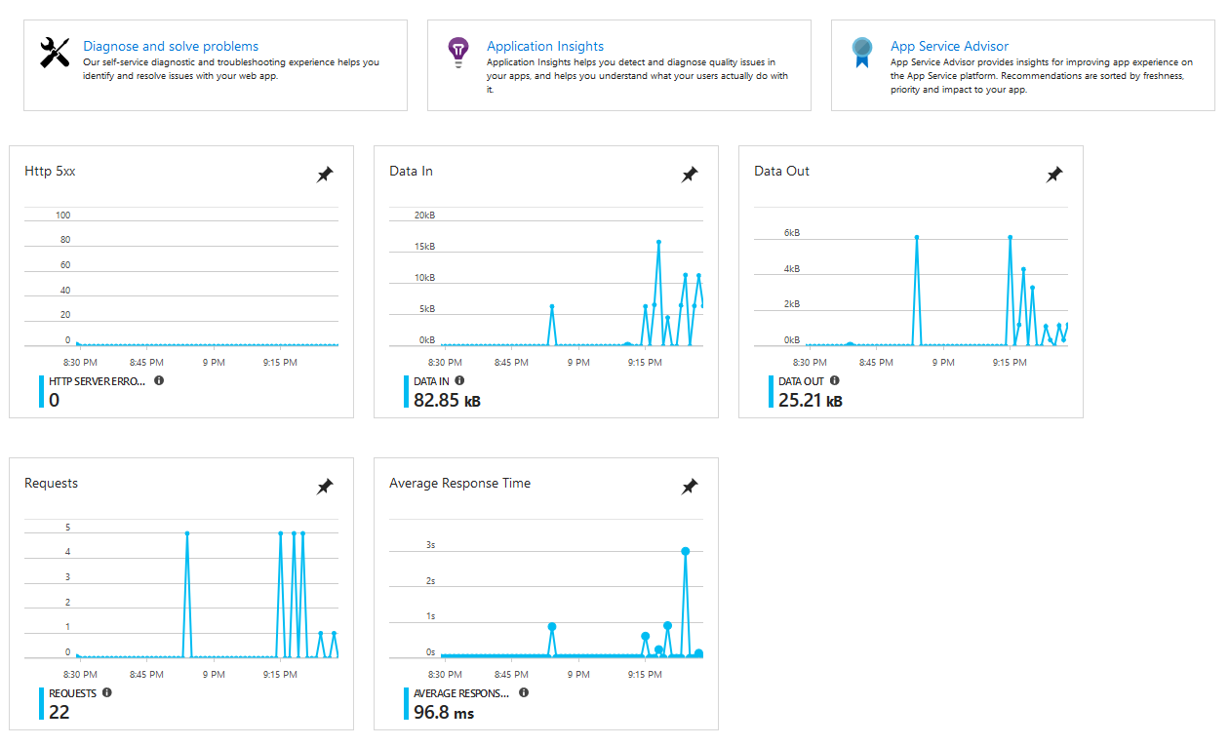

The analytics above show five different charts that each have different use and shows different information, the Requests graph shows how many times a request is sent depending on clicking a link or/and moving around the website in general from link to link, as for the Average Response Time shows the time it takes for the Web App response time and how long it takes to load as this will help the organization to determine if they will need to upscale or have any kind of upgrades depending on the analytics that are shown.

# Conclusion

In conclusion the development process was difficult but successful and very informative and challenging thus the process of deploying was smooth as Azure platform was clear due previous exercises and help during classes therefore seeing the increasing potential of cloud computing and how it is important for everyone from normal individuals who want to run a personal website to huge organizations as Microsoft Azure offers a lot of options which is suitable for everyone as cloud computing is developing every day and new technologies are being available.

**Video Link:**

https://web.microsoftstream.com/video/54633bf4-3905-4598-817b-6289645c2268

# References

Alessandro Castellani. (2016). How to install Apache, MySql and PHP on Windows 10. [Online Video]. 3 January 2016. Available from: <https://www.youtube.com/watch?v=kuMTZowwjus>. [Accessed: 1 April 2018].

Amit Andipara. (2016). dynamic dropdown in HTML and fetching data from mysql using php. [Online Video]. 22 June 2016. Available from: <https://www.youtube.com/watch?v=1I_Ubx2d2tw>. [Accessed: 1 April 2018].

Back 2 Tech. (2016). How to solve/fix Parse error (syntax error) in php - Hindi. [Online Video]. 15 March 2016. Available from: <https://www.youtube.com/watch?v=UtvPwdTqJPo>. [Accessed: 1 April 2018].

Clever Techie. (2017). Login System Tutorial with PHP and MYSQL Database. [Online Video]. 2 February 2017. Available from: <https://www.youtube.com/watch?v=Pz5CbLqdGwM&t>. [Accessed: 1 April 2018].

Code Tutorial. (2014). PHP simple hotel room booking (price varies acording to season) source code. [Online Video]. 1 April 2014. Available from: <https://www.youtube.com/watch?v=D0IbM9NkfWo&t=>. [Accessed: 1 April 2018].

GitHub Training & Guides. (2015). Automating code deployment with GitHub and Azure. [Online Video]. 15 September 2015. Available from: <https://www.youtube.com/watch?v=3WDe3l1M-3U>. [Accessed: 1 April 2018].

James Sherwood-Jones. (2011). Learning PHP - 7 - Simple Login Form. [Online Video]. 20 December 2011. Available from: <https://www.youtube.com/watch?v=psed0RwsbB0&t>. [Accessed: 1 April 2018].

LinkedIn Learning Solutions. (2013). How to install phpMyAdmin on Windows | lynda.com tutorial. [Online Video]. 12 March 2013. Available from: <https://www.youtube.com/watch?v=KFYXY3MT-XA&t>. [Accessed: 1 April 2018].

mmtuts. (2017). 44: How to create a complete login system in PHP (READ DESC) | PHP tutorial | Learn PHP programming. [Online Video]. 20 June 2017. Available from: <https://www.youtube.com/watch?v=xb8aad4MRx8&t>. [Accessed: 1 April 2018].

webpwnized. (2016). How to Install MySQL Server on Windows 10. [Online Video]. 7 January 2016. Available from: <https://www.youtube.com/watch?v=LnOnzNQnJMU>. [Accessed: 1 April 2018].